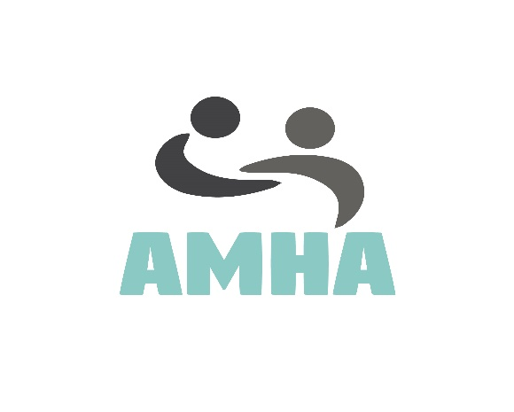

Volunteer Position: Creative Producer
Available positions: Two
Duration: Ongoing from April 2017
Time Commitment: Flexible, potentially a few hours a week.
Location: This will be home based with regular contact with our team online, with a weekly online meeting with our director Sonny to keep you updated and discuss any weekly tasks. Once we gain speed, the director would like to start meeting in person with each of his volunteers in their local area to discuss any updates and get feedback to ensure everyone is happy and clear on the direction our campaign is going.
Description: Our campaign will be dependent on creative content and constant weekly updates to stories, new campaigns, videos, art submissions, working with other organisations and eventually with other professionals. Our aim is to start other campaigns within mental health and autism under the AMHA brand that will require people with a flair for art and design, with heavy use of advanced technology and be able to follow the directors vision.

Although the main bulk of work is being done by the project director, We need someone to help take on the smaller projects to begin with but also help us expand into independently filming stories without external help, aswell animation, 3D printing, outdoor sculptural designs, art installations, and be able to help with our existing website and creative content to keep it fresh, clean, creative and welcoming to those with ASD and Mental Illness, this role will evolve over time and offer you a variety of project work that will be challenging but worthwhile. You will be an important part of our small team.

You will be managed by our project director Sonny Hawkins who will give you guidance, support and timely advise if needed aswell as access to training to help you learn new skills within graphic design, advertising, technology and app design. But also, if you wish to gain optional training to expand your knowledge on Mental Health and Autism with our partners at Clearly Speaking who offered training courses for free. www.clearlyspeaking.org.uk

We are hoping over time to be able to fund a post full time if we can gain funding once our project gains traction, we don’t want to take advantage of volunteers as we know first-hand how demanding and specialised a creative producer can be, so we want in the meantime to offer flexible projects that fit around you while offering experience to be a part of something new and exciting. Once we can consider hiring staff, we will be considering volunteers a post first.

All our volunteer positions are most suited to those with a passion for mental health and autism who want to fix the stigma attached by informing the public and sharing stories to enlighten and engage our audience to get people talking about a subject which is very difficult for some and very misunderstood.

Who are we looking for?
You must be 18+ yrs old due to some of the difficult material we receive through submissions. We would like to find someone with the following requirements:

- Must be able to effectively communicate via written language and can communicate about sensitive subjects suchas mental illness and autism.

- Must be competent with technology and have ideas and a want/passion to try different creative techniques, or technologies which enable us to portray stories in a different media​

- It would be nice if you had advertising experience and website design (not coding side, but graphical design) with an eye for detail.

- Must be fluent in English

- We are looking for someone with skills in any of the following, Adobe Photoshop, Illustrator, other image editing software like 3D max, Video editing, Photography, illustration, fine art, Screen printing, 3D Printing, Sculptural work, blogging, fluent in word processing suchas MS Word, PowerPoint, Excel, Publisher, Access. (or anything else you might use personally you think we would befit from)

- As an absolute must, you need to be dependable, independent as you will be working mostly on your own being this will be home base and be trusted to carry out weekly tasks. We will expect you to contact us if any issues occur and to work with our little virtual team.
Who can Apply?
We encourage all to apply whether you are a student, disabled and stuck at home, someone who is looking to gain some experience, or perhaps you may be retired. As long as you meet the above requirements, we welcome you to apply via our website.
If you are unsure of anything to do with this volunteer position or about our new Campaign AMHA | Autism and Mental Health Awareness, Please get in touch via our email info@amha.org.uk Alternatively you can contact us via any of our social media accounts as advertised or please fill out our online contact form.
Once we receive you application, we will b in touch very soon to discuss the role in more detail.

