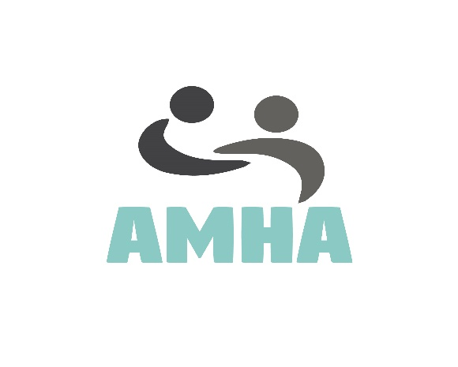

Volunteer Position: Content editior
Available positions: One
Duration: Ongoing from April 2017
Time Commitment: Flexible, potentially a few hours a week.
Location: This will be home based with regular contact with our team online, with a weekly online meeting with our director Sonny to keep you updated and discuss any weekly tasks. Once we gain speed, the director would like to start meeting in person with each of his volunteers in their local area to discuss any updates and get feedback to ensure everyone is happy and clear on the direction our campaign is going.
Description: Our most important platform for sharing stories to the public will start with our website, this website is only the beginning, once we launch in spring 2017, we have big plans to continue expansion and create new content to continue our efforts in campaigning for mental health and autism.
While these expansion plans are important, we need help in continuing the project directors work of collecting, editing and creating contributor stories which will come in many forms of media suchas art, videos, blogs and more. We will need help to go through submissions and add them to our website, along with creating appropriate advertising and social media posts.
We would also like to find editors to have your own blogs and write about mental health / autism stories on a website on a weekly/monthly basis so this role is especially encouraged to those with mental health or autism. (Although this is optional)
You will be managed by our project director Sonny Hawkins who will give you guidance, support and timely advise if needed aswell as access to training to help you learn new skills within graphic design, advertising, technology and app design. But also, if you wish to gain optional training to expand your knowledge on Mental Health and Autism with our partners at Clearly Speaking who offered training courses for free. www.clearlyspeaking.org.uk

All our volunteer positions are most suited to those with a passion for mental health and autism who want to fix the stigma attached by informing the public and sharing stories to enlighten and engage our audience to get people talking about a subject which is very difficult for some and very misunderstood.

Who are we looking for?
You must be 16+ yrs old due to some of the difficult material we receive through submissions. We would like to find someone with the following requirements:

- Must be able to effectively communicate about sensitive subjects

- It would be of benefit to you to have abroad knowledge or at least willing to learn of Autism and Mental Health as you will need to understand and assist submitters with their uploads to our site and ensure they are contacted once its live.

- Must be competent with technology like website content editing or again willing to learn, (we are currently using a website builder wix.com until we have time to custom build a fully coded website)

- You have ideas and a want/passion to try different ideas on adding content to our website and social media​ including the style and design of how the content will appear. So a good eye for detail is a must.

- It would be nice if you had advertising experience

- As an absolute Must, you need to be fluent in English with good spelling and grammar as we tend to spend much time editing stories so they are appropriate for the website. (although we will add for those with learning disabilities, our director would personally like to supervise you to help you have an opportunity at content editing)

- Obviously, you need to be familiar with work processing on a pc suchas MS Word, open docs, page or any other chosen format that you might use.

- We will expect you to carry out tasks given and use your own initiative once we have shown you the ropes.

- You need to be dependable, independent as you will be working mostly on your own being this will be home base and be trusted to carry out tasks as directed. We will expect you to contact us if any issues occur and to work with our small online team.
Who can Apply?
We encourage all to apply whether you are a student, disabled and stuck at home, someone who is looking to gain some experience, or perhaps you may be retired. As long as you meet the above requirements, we welcome you to apply via our website.
If you are unsure of anything to do with this volunteer position or about our new Campaign AMHA | Autism and Mental Health Awareness, Please get in touch via our email info@amha.org.uk Alternatively you can contact us via any of our social media accounts as advertised or please fill out our online contact form.
Once we receive you application, we will b in touch very soon to discuss the role in more detail.

